Workspace Setup DOC

## Steps for React Workspace Setup

1. Download the Summer_Intership_UI and extract the folder.
2. Open the folder with VS code.
3. Open a new terminal in VS code **(Ctrl+Shift+`)** and use **npm install** commandfor installing node_modules in the project:

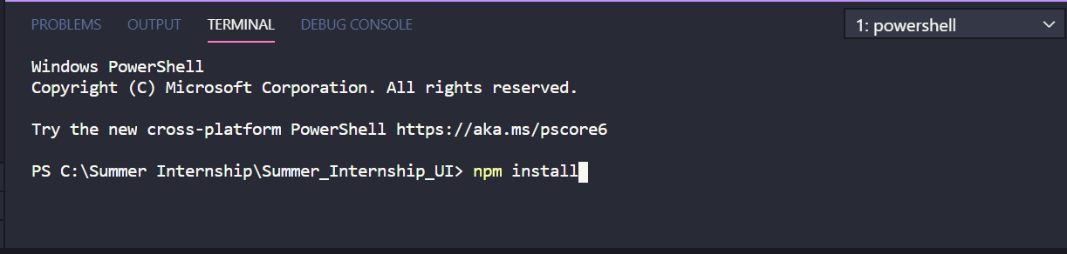

1. After installing, use **npm start** to start the server:

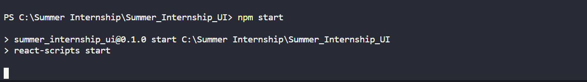

1. Open constant.js from utils/constant.js and replace the ROLL_NUMBER constant with your roll number

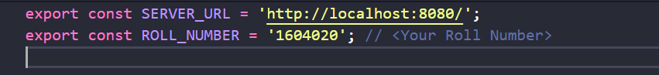

1. Open package.json and replace <YOUR_ROLL_NUMBER> in homepage url with your roll number

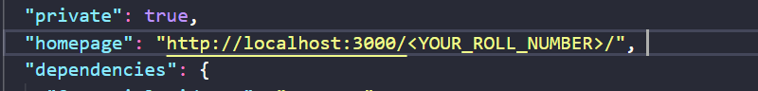

1. Best Of Luck ! **👍**